**Assignment-** **Statistics and Probability Theory**

**Q1.** Explain the difference between descriptive and inferential statistics. Provide examples of

each.

Ans. descriptive statistics is about summarizing and understanding the characteristics of a dataset, while inferential statistics is about using a sample to make predictions or inferences about a larger population.

Descriptive statistics describe the data at hand, while inferential statistics make predictions or inferences about a larger population based on the sample data

Descriptive statistics work on a complete dataset to summarize it, whereas inferential statistics use sample data to generalize about a population.

descriptive statistics involve calculations like mean, median, mode, and creating graphs whereas inferential statistics involves analyses like hypothesis testing, confidence intervals, and regression models.

**Examples: Descriptive Statistics**

1. **Mean Calculation**: If you have test scores for a class of 30 students, the average (mean) score is a descriptive statistic.
2. **Histogram**: Creating a histogram to show the distribution of ages in a community.
3. **Standard Deviation**: Calculating the standard deviation of heights in a sample of 50 people to understand how spread out the heights are.

**Examples: Inferential Statistics**

1. **Confidence Interval**: Estimating the average height of all high school students in a city based on a sample of 200 students. If the sample mean height is 165 cm, you might calculate a 95% confidence interval to be from 162 cm to 168 cm, suggesting that you are 95% confident the true mean height of all high school students in the city falls within this range.
2. **Hypothesis Testing**: Testing whether a new drug is more effective than the current standard treatment by comparing the recovery rates of patients using both drugs.
3. **Regression Analysis**: Predicting house prices based on various factors like square footage, number of bedrooms, and location. By analyzing a sample of house sales, you develop a model that can predict prices for other houses.

Q2.Define the Central Limit Theorem and discuss its significance in statistical inference.

Ans. CLT defines as when you take a sample from any population with any shape distribution , the distribution of the sample mean will be like that of a normal distribution.

This normal distribution will have the mean equal to the population mean and variance equal to the population variance divided by the sample size.

**Significance in Statistical Inference**

1. **Foundation for Confidence Intervals**: The CLT allows us to construct confidence intervals for population parameters. For example, if we want to estimate the population mean μ\muμ using the sample mean Xˉ\bar{X}Xˉ, we can say that Xˉ\bar{X}Xˉ follows a normal distribution for large nnn, which lets us calculate the confidence intervals accurately.
2. **Hypothesis Testing**: Many statistical tests, such as t-tests and z-tests, rely on the assumption that the test statistic follows a normal distribution. The CLT justifies this assumption for large sample sizes, making it possible to test hypotheses about population parameters.
3. **Approximation of Distributions**: In practical scenarios, the exact distribution of the sum or mean of random variables is often unknown or complex. The CLT provides a way to approximate these distributions with the normal distribution, simplifying analysis and calculations.
4. **Simplifies Analysis of Non-Normal Data**: Even if the original data does not follow a normal distribution, the CLT ensures that the sampling distribution of the mean will be approximately normal for large samples. This is particularly useful when dealing with skewed or otherwise non-normal populations.
5. **Basis for Other Statistical Methods**: Many advanced statistical methods, including regression analysis and analysis of variance (ANOVA), rely on the normality assumption for the distribution of errors. The CLT helps to satisfy this assumption when dealing with large samples.

Q3. Discuss the concept of sampling and its role in statistical analysis.

Ans. Sampling is the process of selecting a subset of individuals or observations from a larger population to make inferences about the entire population. It is a fundamental aspect of statistical analysis, as it allows researchers to gather data and perform analyses without needing to survey or examine every member of the population.

### Importance of Sampling in Statistical Analysis

1. **Generalization**: Proper sampling techniques allow researchers to generalize findings from the sample to the broader population. This is the basis for making valid inferences and predictions.
2. **Precision**: Sampling helps achieve precision in estimates. By controlling for factors such as sample size and variability, researchers can obtain accurate estimates of population parameters.
3. **Bias Reduction**: Well-designed sampling methods minimize bias, ensuring that the sample accurately reflects the population. This is critical for the validity of statistical analyses and conclusions.
4. **Hypothesis Testing**: Sampling is essential for hypothesis testing, where researchers make inferences about population parameters based on sample statistics. For example, determining whether a new drug is more effective than a placebo involves comparing sample data from treatment and control groups.

Q4. Explain the process of hypothesis testing and the key components involved.

Ans. Hypothesis testing is a statistical method used to make inferences about population parameters based on sample data. It involves formulating and testing assumptions (hypotheses) to determine whether there is enough evidence to support a specific claim

**Process of Hypothesis Testing**

1. **Formulate Hypotheses**:
   * **Null Hypothesis (H0)**: This is the default assumption or claim that there is no effect or no difference. It is a statement to be tested and is assumed true until evidence suggests otherwise. For example, H0H0H0: The mean weight of bags of flour is 1 kg.
   * **Alternative Hypothesis (H1 or Ha)**: This is the statement that contradicts the null hypothesis. It represents what the researcher wants to prove. For example, HaHaHa: The mean weight of bags of flour is not 1 kg.
2. **Choose the Significance Level (α)**:
   * The significance level, commonly denoted by α, is the probability of rejecting the null hypothesis when it is actually true (Type I error). Typical values for α are 0.05, 0.01, or 0.10.
3. **Select the Appropriate Test Statistic**:
   * The test statistic is a standardized value calculated from sample data. It is used to determine how far the sample statistic is from the null hypothesis. Common test statistics include the z-score, t-score, chi-square, and F-statistic, depending on the nature of the data and hypotheses.
4. **Determine the Sampling Distribution**:
   * Under the null hypothesis, determine the distribution of the test statistic. This could be a normal distribution, t-distribution, chi-square distribution, etc.
5. **Calculate the Test Statistic**:
   * Compute the test statistic using sample data. The formula for the test statistic varies depending on the test being used (e.g., z-test, t-test).
6. **Find the P-value or Critical Value**:
   * **P-value**: The p-value is the probability of obtaining a test statistic as extreme as, or more extreme than, the one observed, assuming the null hypothesis is true. A small p-value (less than α) indicates strong evidence against the null hypothesis.
   * **Critical Value**: Alternatively, compare the test statistic to a critical value from the sampling distribution corresponding to the chosen significance level. If the test statistic falls in the critical region, reject the null hypothesis.
7. **Make a Decision**:
   * Based on the p-value or comparison with the critical value, decide whether to reject or fail to reject the null hypothesis.
   * **Reject H0**: If the p-value is less than α or the test statistic exceeds the critical value, reject the null hypothesis in favor of the alternative hypothesis.
   * **Fail to Reject H0**: If the p-value is greater than α or the test statistic does not exceed the critical value, do not reject the null hypothesis.
8. **Draw a Conclusion**:
   * Interpret the results in the context of the original research question or claim. State whether there is sufficient evidence to support the alternative hypothesis.

**Key Components Involved in Hypothesis Testing**

1. **Null Hypothesis (H0)**: The assumption being tested, typically a statement of no effect or no difference.
2. **Alternative Hypothesis (H1 or Ha)**: The claim being tested against the null hypothesis, indicating the presence of an effect or difference.
3. **Significance Level (α)**: The threshold for deciding whether to reject the null hypothesis, representing the probability of a Type I error.
4. **Test Statistic**: A numerical value calculated from the sample data used to decide whether to reject the null hypothesis.
5. **P-value**: The probability of observing a test statistic as extreme as the one computed, assuming the null hypothesis is true.
6. **Critical Value**: The value that the test statistic must exceed to reject the null hypothesis, based on the significance level and the sampling distribution.
7. **Decision Rule**: The criterion for rejecting or failing to reject the null hypothesis, based on the p-value or critical value comparison.
8. **Conclusion**: The final interpretation of the hypothesis test, relating the statistical decision back to the context of the research question.

Q5. Describe the T-distribution and how it differs from the normal distribution.

Ans. The t-distribution is a probability distribution used in statistics, particularly in hypothesis testing and confidence interval estimation for small sample sizes or when the population variance is unknown.

**Differences from the Normal Distribution**

1. **Tail Behavior**:
   * **T-Distribution**: Heavier tails, meaning there is more probability in the tails than in the normal distribution. This reflects greater uncertainty and accounts for the variability due to smaller sample sizes.
   * **Normal Distribution**: Lighter tails, with most of the data clustering around the mean.
2. **Degrees of Freedom**:
   * **T-Distribution**: Varies with the degrees of freedom. With fewer degrees of freedom, the t-distribution is more spread out. As the degrees of freedom increase, it becomes narrower and more similar to the normal distribution.
   * **Normal Distribution**: Does not depend on degrees of freedom. It is a fixed distribution characterized by its mean and standard deviation.
3. **Application**:
   * **T-Distribution**: Used for hypothesis testing and constructing confidence intervals for small sample sizes or when the population standard deviation is unknown. Common applications include t-tests (one-sample, paired, and independent two-sample t-tests).
   * **Normal Distribution**: Used when dealing with large sample sizes (n ≥ 30) or when the population standard deviation is known. Applications include z-tests and many inferential statistics techniques.

**Visual Comparison**

Imagine overlaying the t-distribution and the normal distribution on the same graph:

* The **t-distribution** curve is lower and wider, with fatter tails, especially for small degrees of freedom.
* The **normal distribution** curve is taller and narrower, with thinner tails.

**Practical Example**

Suppose a researcher wants to estimate the mean height of a specific plant species based on a small sample of 15 plants. The population variance is unknown.

* The researcher would use the **t-distribution** to construct a confidence interval for the mean height because the sample size is small (n = 15) and the population variance is unknown. The degrees of freedom would be 14 (n - 1).
* If the sample size were large, say 100 plants, and/or the population variance were known, the **normal distribution** would be used for the confidence interval.

**Differences from the Normal Distribution**

1. **Tail Behavior**:
   * **T-Distribution**: Heavier tails, meaning there is more probability in the tails than in the normal distribution. This reflects greater uncertainty and accounts for the variability due to smaller sample sizes.
   * **Normal Distribution**: Lighter tails, with most of the data clustering around the mean.
2. **Degrees of Freedom**:
   * **T-Distribution**: Varies with the degrees of freedom. With fewer degrees of freedom, the t-distribution is more spread out. As the degrees of freedom increase, it becomes narrower and more similar to the normal distribution.
   * **Normal Distribution**: Does not depend on degrees of freedom. It is a fixed distribution characterized by its mean and standard deviation.
3. **Application**:
   * **T-Distribution**: Used for hypothesis testing and constructing confidence intervals for small sample sizes or when the population standard deviation is unknown. Common applications include t-tests (one-sample, paired, and independent two-sample t-tests).
   * **Normal Distribution**: Used when dealing with large sample sizes (n ≥ 30) or when the population standard deviation is known. Applications include z-tests and many inferential statistics techniques.

**Visual Comparison**

Imagine overlaying the t-distribution and the normal distribution on the same graph:

* The **t-distribution** curve is lower and wider, with fatter tails, especially for small degrees of freedom.
* The **normal distribution** curve is taller and narrower, with thinner tails.

**Practical Example**

Suppose a researcher wants to estimate the mean height of a specific plant species based on a small sample of 15 plants. The population variance is unknown.

* The researcher would use the **t-distribution** to construct a confidence interval for the mean height because the sample size is small (n = 15) and the population variance is unknown. The degrees of freedom would be 14 (n - 1).
* If the sample size were large, say 100 plants, and/or the population variance were known, the **normal distribution** would be used for the confidence interval.

Q5 Calculate the mean, median, and standard deviation for the following dataset: [10, 15, 20, 25,30]

Ans.

|  |  |
| --- | --- |
| Mean | 20 |
| Mode | NO Mode |
| Median | 20 |

Q6 A researcher wants to estimate the average height of students in a university. She samples 50 students and finds the mean height to be 65 inches with a standard deviation of 3 inches. Construct a 95% confidence interval for the population mean height

Ans

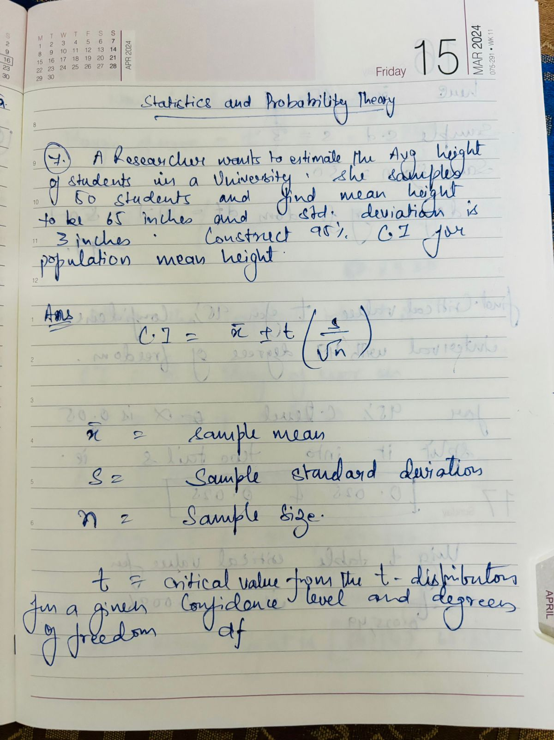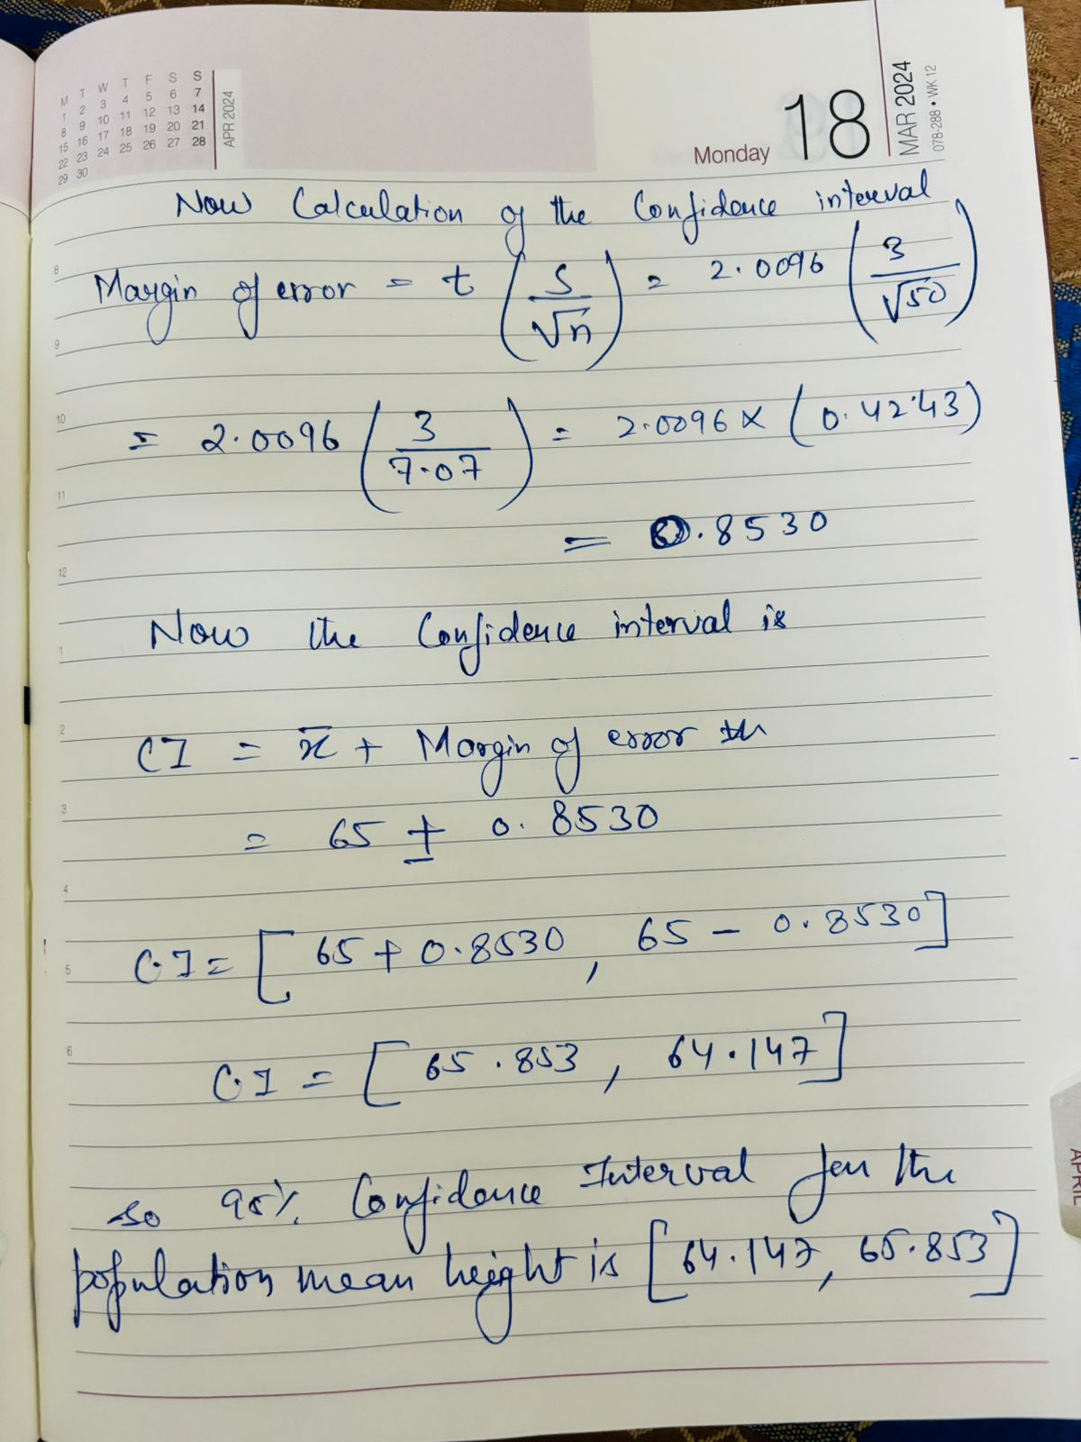

A manufacturer claims that the average lifespan of its light bulbs is 1000 hours. A random

sample of 50 light bulbs has a mean lifespan of 980 hours with a standard deviation of 50 hours.

Test the manufacturer's claim at a significance level of 0.05 using a right-tailed hypothesis test.

Ans.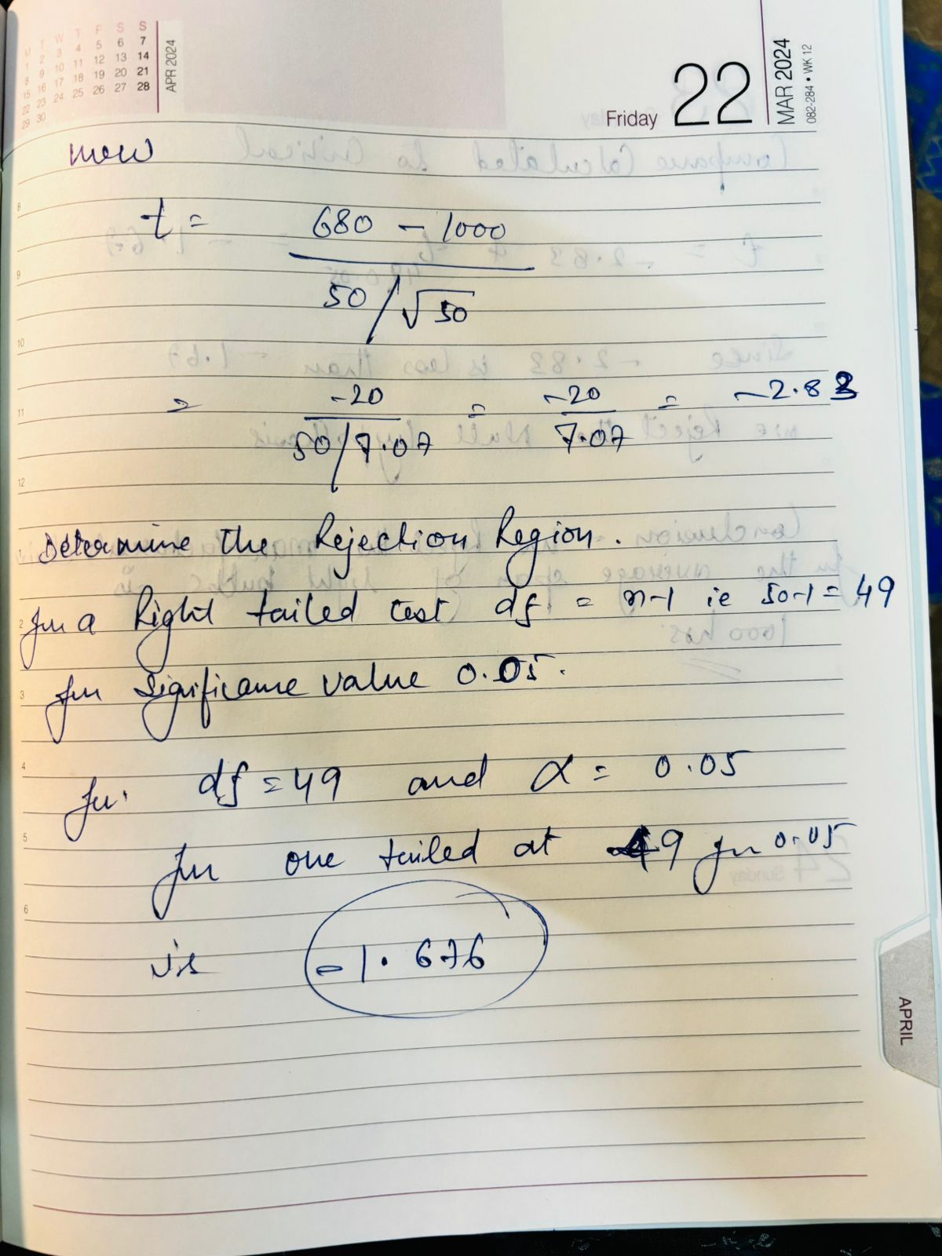

1. A pharmaceutical company is testing a new drug for lowering blood pressure. They want to determine if the drug is effective in reducing blood pressure levels. State the null and alternative hypotheses for this study.

Ans.

In the context of the pharmaceutical company's study to determine if a new drug is effective in reducing blood pressure levels, the hypotheses can be stated as follows:

* **Null hypothesis (H0)** The new drug has no effect on blood pressure levels.

H0​:μd​=0

• where μd is the mean difference in blood pressure levels before and after taking the drug.

**Alternative hypothesis (Ha)**: The new drug is effective in reducing blood pressure levels.

Ha: μd​<0

his hypothesis setup assumes that the company expects a decrease in blood pressure as a result of taking the drug. The null hypothesis states that there is no change, while the alternative hypothesis states that there is a decrease in blood pressure levels.

10. A quality control manager at a factory wants to ensure that the average weight of products

coming off the production line is 500 grams. She takes a random sample of 30 products and

finds the mean weight to be 495 grams with a standard deviation of 10 grams. Test the

manager's claim at a significance level of 0.01 using a left-tailed hypothesis test.

Ans.

